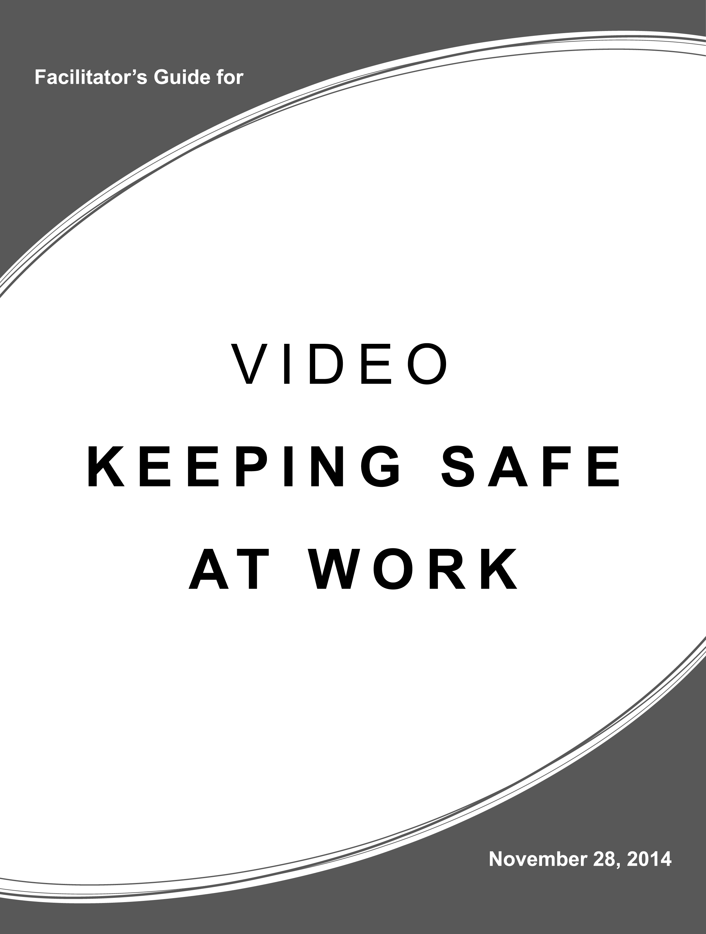

Table of Contents

Welcome! 1
Part 1: Using Essential Skills and Work Habits to Stay Safe at Work 2
Part 2: The Occupational Health and Safety Act (OHSA) 5
Part 3: The Workplace Hazardous Materials Information System (WHMIS) 9
Part 4: Risks, Hazards, Rights, Responsibilities and Other Safety Considerations 11
Part 5: Tips for Staying Safe at Work and Compliance Worksheet 13
Part 6: Video Script and Health & Safety Teaching Notes 15
Appendix 1: Essential Skills Activity Set 22
Appendix 2: Additional Resources 37

Welcome!

The video, Keeping Safe at Work, was co-sponsored by the Ontario Ministry of Education and the Ministry of Labour and is intended for use with learners, job seekers and workers.
This guide to the video is designed to provide additional information for facilitators using the video and includes:
- A set of worksheets to help learners, job seekers and workers better understand the Essential Skills and work habits necessary for staying safe at work
- Background information on the rights, responsibilities and legislation involved in ensuring workers and workplaces are safe
- Frequently asked questions and their answers related to worker and workplace safety
- Tip sheets for staying safe at work and compliance worksheets that may be copied and used with learners, job seekers and workers
- A complete copy of the script for the video Keeping Safe at Work
- A matrix showing when during the video different health and safety teaching points may be most effectively included in your instruction with space to include your own observations
- An Essential Skills Activity Set focused on occupational health and safety
- A list of additional resources
Learning Goals
The video Keeping Safe at Work was developed to provide learners, job seekers and workers with the opportunity to:
- Observe Essential Skills and work habits in use, especially Critical Thinking
- Observe workplace safety rights and responsibilities in use

IMPORTANT: This document does not constitute legal advice.

To determine your rights and obligations under the Occupational Health and Safety Act (OHSA) and its regulations, please contact your legal counsel or refer to the legislation at
http://www.e-laws.gov.on.ca/html/statutes/english/elaws_statutes_90o01_e.htm

Part 1: Using Essential Skills and Work Habits to Stay Safe at Work

The following worksheets can be used with groups of learners, job seekers and workers or provided for individual study. For more information on how to connect Essential Skills and work habits to your teaching, please refer to A Guide to Linking Essential Skills and the Curriculum.
Essential Skills and Work Habits Checklist
- Provide a copy of the checklist to individual learners, or to learners working in pairs.
- Review the language on the checklist clarifying any terms that may be unfamiliar.
- Ask the learners to put a checkmark in the corresponding box each time they see an Essential Skill or work habit being used in the video. Share with the learners that some of the Essential Skills and work habits are identified for them in the video but there are others in use that they can identify for themselves.
- Compare results and discuss findings.

  - Critical Thinking Worksheet
- Provide a copy of the worksheet to individual learners, or to learners working in pairs.
- Review the questions on the worksheet before watching the video.
- Ask the learners to complete the worksheet and compare results and discuss findings.

  - Sample Essential Skills Activity Set
The SkillsZone website (http://www.skillszone.ca/cesl/search/index.cfm) provides hundreds of Essential Skills activity sets showing how the skills are used in the workplace. Many of the sets are focused on occupational health and safety. As an example, the activity, NOC 7293 – Heat and Frost Insulators – MSDS, is included in this guide in Appendix 1 and instructions for completion are provided with the activity.
Additional activity sets available on SkillsZone and related to health and safety include:
- NOC 9617 - Labourers in Food, Beverage and Tobacco Processing - Equipment Lock-Out Procedure
- NOC 9619 - Other Labourers in Processing, Manufacturing and Utilities - Watch Your Back
- NOC 9616 - Labourer in Textile Processing - Health and Safety Regulations
- NOC 8411 - Underground Mine Service and Support Worker - Blasting Procedures
- NOC 74 - Intermediate Occupations in Transport, Equipment Operation, Installation and Maintenance - Workplace Safety Symbols and Labels
- NOC 7371 - Crane Operators - Safe Work Loads

Essential Skills and Work Habits in the OSP Videos
Check off the Essential Skills and work habits that are demonstrated in the video.

Video Title: ______________________________________________________

Name(s): ______________________________________________________
 | OSP Icon | Essential Skill
 |  | Reading Text
 |  | Writing
 |  | Document Use
 |  | Computer Use
 |  | Oral Communication
 |  | Money Math
 |  | Scheduling or Budgeting and Accounting
 |  | Measurement and Calculation
 |  | Data Analysis
 |  | Numerical Estimation
 |  | Job Task Planning and Organizing
 |  | Decision Making
 |  | Problem Solving
 |  | Finding Information
 |  | Critical Thinking

 | OSP Icon | Work Habit
 |  | Working Safely
 |  | Teamwork
 |  | Reliability
 |  | Organization
 |  | Working Independently
 |  | Initiative
 |  | Self-Advocacy
 |  | Customer Service
 |  | Entrepreneurship

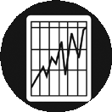

Skill levels are provided for each Essential Skill. Level
1 tasks are the least complex and level 4/5 are the
most complex. Please note that there are no skill levels associated with the OSP work habits.

ontario.ca/skillspassport

Essential Skills & Work Habits Critical Thinking
Video Worksheet

- Critical Thinking is one of the main Essential Skills shown at use in the video. The definition of critical thinking is: “Making judgments by using criteria to evaluate ideas and information and the related consequences.” Rewrite this definition in your own words.
- What are two important things that you remember about this skill from the video?
a)

b)

- As all Essential Skills and work habits are transferable, provide an example to show how you would use this skill in each of the following contexts. If you don’t think you have used this skill yet, describe a situation where you think you could use it. When finished, share your ideas with a partner.
- Work:

- Learning:

- Life:

Part 2: The Occupational Health and Safety Act (OHSA)

The following information has been provided by the Ontario Ministry of Labour and is based on information from the following website:
http://www.e-laws.gov.on.ca/html/statutes/english/elaws_statutes_90o01_e.htm

2.1 What is the purpose of OHSA?
The main purpose of the Occupational Health and Safety Act (OHSA) is to protect workers from health and safety hazards on the job.
It sets out the duties that workers, supervisors and employers must comply with to keep workplaces safe and healthy. OHSA also sets out the rights workers are entitled to. OHSA establishes procedures for dealing with workplace hazards and provides for enforcement of the law where compliance has not been achieved voluntarily.
2.2 What rights does OHSA give workers?
OHSA provides workers with three important rights:
- The right to know
- The right to participate
- The right to refuse
2.3 The 3 R’s Worker’s basics rights under the OHSA
1. The right to know
The right to know about any hazards to which they may be exposed. The requirements of the Workplace Hazardous Material Information System (WHMIS) are an important example.
You have the right to know about hazards in your workplace and to be trained how to protect yourself from harm. As of July 1, 2014, the law requires employers to make sure that all of their workers and supervisors have completed basic health and safety awareness training. This training outlines workers’, supervisors’ and employers’ rights, roles and responsibilities in keeping workplaces safe and healthy. This basic training for all workers and supervisors is in addition to other more detailed training required by law that depends on your workplace. See 2.7 & 2.8 for more information on the mandatory awareness training for workers and supervisors.
2. The right to participate
The right to participate to be part of the process of identifying and resolving health and safety concerns.
The main way that workers can participate in workplace health and safety is through exercising their rights and duties in a responsible manner and by supporting their Joint Health and Safety Committee (JHSC). The JHSC is made up of worker and management representatives and has the power to:
- Identify hazards
- Obtain information from the employer
- Make recommendations to employer
- Investigate work refusals
- Investigate serious accidents
- Act as a worker health and safety representative
- Participate on the joint health and safety community
You also have the right to help identify and resolve workplace health and safety concerns. There are many ways you can do this, such as asking questions, raising concerns and giving positive feedback. One of the most effective ways you can get involved is to join the health and safety committee at your workplace.
  - The right to refuse
The right to refuse work that they believe is dangerous.
You have the right to refuse unsafe work, including situations where you believe you’re in danger of workplace violence. Your employer cannot fire or discipline you for refusing unsafe work or for asking them to address a health and safety issue. Your employer can’t penalize you for following workplace health and safety laws and for obeying a Ministry of Labour inspector’s order. This would be an unlawful reprisal.
Health and safety concerns, hazards or violations of workplace health and safety law should immediately be brought to the attention of the employer or supervisor. If nothing is done, it can be taken to the worker's health and safety representative or Joint Health and Safety Committee. If you can’t get health and safety problems fixed at work, call the Ministry of Labour Health and Safety Contact Centre toll-free at 1-877-202-0008. You don’t have to give your name. Services are offered in multiple languages, in addition to English and French.
2.4 When can a worker refuse to work?
A worker can refuse to work if he or she has reason to believe that:
- any machine, equipment or tool that the worker is using or is told to use is likely to endanger himself or herself or another worker [clause 43(3)(a)]
- the physical condition of the workplace or workstation is likely to endanger himself or herself [clause 43(3)(b)]
- workplace violence is likely to endanger himself or herself [clause 43(3)(b.1)]
- any machine, equipment or tool that the worker is using, or the physical condition of the workplace, contravenes the Act or regulations and is likely to endanger himself or herself or another worker [clause 43(3)(c)].
The worker must immediately tell the supervisor or employer that the work is being refused and explain the circumstances for the refusal [subsection 43(4)].

2.5 Do workers have duties under OHSA? What are they?
Yes. Workers have a general duty to take responsibility for personal health and safety, which means they should not behave or operate equipment in a way that would endanger themselves or others. Section 28 of OHSA lists additional specific worker duties:
- Work in compliance with the Act and regulations;
- Use any equipment, protective devices or clothing required by the employer;
- Tell the employer or supervisor about any known missing or defective equipment or protective device that may be dangerous;
- Report any known workplace hazard or violation of the Act to the employer or supervisor;
- Not remove or make ineffective any protective device required by the employer or by the regulations.
2.6 Do supervisors have duties under OHSA? What are they?
Yes. The Act sets out certain specific duties for supervisors. A supervisor means a person who has charge of a workplace or authority over a worker. A supervisor must:
- ensure that a worker complies with the Act and regulations [section 27(1)(a)];
- ensure that any equipment, protective device or clothing required by the employer is used or worn by the worker [section 27(1)(b)];
- advise a worker of any potential or actual health or safety dangers known by the supervisor [section 27(2)(a)]; and
- take every precaution reasonable in the circumstances for the protection of workers [section 27(2)(c)].
2.7 Do employers have duties under OHSA? What are they?
Yes. OHSA Sections 25 assigns a mixture of general and specific duties to employers and provides for other duties to be prescribed (required) by regulation. Some of the general duties require an employer to:
- Take all reasonable precautions to protect the health and safety of workers;
- Ensure that equipment, materials and protective equipment are maintained in good condition;
- Provide information, instruction and supervision to protect worker health and safety, including the mandatory basic awareness training for workers and supervisors and
- Co-operate with the JHSC.
2.8 What is the mandatory basic awareness training required under OHSA?
- The basic awareness training raises general awareness about the duties and rights of workers and supervisors under the Occupational Health and Safety Act (OHSA) and raises awareness about common workplace hazards.
- All employers must ensure workers and supervisors complete, or have completed, an awareness training program that meets the regulatory requirements
Please note that the basic occupational health and safety awareness training requirement does not replace or diminish any other hazard-specific, sector-specific or competency-specific training that may be required for supervisors or workers elsewhere in the OHSA or regulations.
2.9 What are the Regulatory Requirements under the Occupational Health and Safety Awareness and Training Regulation?
- Employers must ensure workers complete an awareness training program as soon as reasonably possible after a worker starts performing work for that employer and for within one week for a supervisors beginning work as a supervisor. The employer must maintain a record of the training completed by workers and supervisors and provide a worker or supervisor with written proof of completion of the training, if requested by the worker or supervisor (up to six months after ceasing to work for the employer).
Please note that basic awareness training does not replace or diminish other Occupational Health and Safety Act (OHSA) training obligations. For example, employers have OHSA duties to provide information and instruction to workers about workplace-specific hazards (such as the WHMIS training), including duties to:
- provide information, instruction and supervision to a worker to protect the worker’s health and safety [OHSA Section 25(2)(a)] and
- acquaint a worker or a person in authority over a worker with any hazard in the workplace and on the handling, storage, use, disposal and transport of any article, device, equipment or a biological, chemical or physical agent [OHSA Section 25(2)(d)].

Part 3: The Workplace Hazardous Materials Information System (WHMIS)

The following information has been provided by the Ontario Ministry of Labour and is based on information from the following website: http://www.labour.gov.on.ca/english/hs/pubs/whmis/

In Ontario, the Workplace Hazardous Materials Information System (WHMIS) legislation applies to all workplaces covered by the Occupational Health and Safety Act and is enforced by provincial Ministry of Labour inspectors.
There are two (2) pieces of provincial legislation that implement WHMIS in Ontario”
- The Occupational Health and Safety Act places duties on employers in charge of workplaces where hazardous materials are used, to obtain labels and material safety data sheets from their suppliers and to provide worker education programs .
- The WHMIS Regulation, Ontario Regulation 644/88 sets out in detail the employer duties respecting labels, material safety data sheets and worker education.
The purpose of WHMIS is to give all working Canadians a uniform and appropriate quantity and quality of information about hazardous materials used in the workplace.
Many Canadian workers are exposed to hazardous materials on the job. In the past, information about these materials has often been incomplete, inconsistent or not available at all. This means that employers and workers were often unaware of the hazards of a material in the workplace, and of the necessary handling precautions. This lack of awareness can cause serious occupational illness and injury.
By setting standards for the type and amount of information to be given to the users of hazardous materials, it is expected that accidents and diseases caused by hazardous materials in the workplace will be reduced.
3.1 Do fire extinguishers require WHMIS labels?
Depending upon what type of extinguisher it is, a fire extinguisher may be classified as a controlled product. Many extinguishers will meet the compressed gas criteria and will therefore require a WHMIS label. Additionally, the characteristics of the extinguishing medium need to be addressed.
3.2 A contract janitorial service does the cleaning in our office. Who is responsible for training the cleaning staff?
The owner or employer of the janitorial service is responsible for training his or her employees regarding the controlled products they use. If the cleaning staffs work in proximity to any controlled products used in the office, then the owner or employer of the office would be required to give information about the products to the janitorial service. The employer of the janitorial service would then be required to train his or her employees on these additional controlled products.
3.3 If I use a pesticide in my workplace are there any WHMIS requirements that I have to comply with?
If the pesticide is also a controlled product, the employer is required to train the workers who use or work in proximity to the pesticide. Additionally, any time the product is transferred into another container, such as a sprayer, a workplace label would be required for the second container.
3.4 Am I allowed to turn the training program over to the worker side of the Health and Safety Committee and ask them to develop it?
Under the Occupational Health and Safety Act, the employer has a clear responsibility to provide training to his/her workers. If the employer so wishes, he/she may delegate the development and implementation of the training program to the Health and Safety Committee. It must be emphasized that this in no way relinquishes the employer from fulfilling his/her duties to ensure that the training is developed and provided.
3.5 Do volunteer workers at a hospital require training regarding any controlled products they may use?
No. Training on the use of controlled products is only required for workers under the Occupational Health and Safety Act. As volunteers do not meet the definition of a worker, no training is legally required. However, employers are strongly encouraged to train volunteers who handle controlled products, or are exposed to any other potential workplace hazards. Although not legally required, providing such training can only be considered part of being a responsible employer.

Part 4: Risks, Hazards, Rights, Responsibilities and Other Safety Considerations

The following information has been provided by the Ontario Ministry of Labour and is based on information from the following website:
http://www.e-laws.gov.on.ca/html/statutes/english/elaws_statutes_90o01_e.htm
4.1 What is a risk? How is it different from a hazard?
a. The hazard posed by some material or situation is its potential to cause harm.
b. Risk is the probability, or chance, that it actually will harm someone.
Removing occupational hazards is only one way of improving worker protection. What is often more practical is the control or management of the risks that hazards pose. Sometimes, in addition to the probability of a hazard causing harm, risk includes a consideration of the seriousness of the hazard.
The consequences of exposure to some hazards may be so harmful that, even if there is little chance of a worker being exposed, the risk is so great that extreme precautions must be taken to prevent even that small possibility.
4.2 What are the two (2) categories that occupational hazards can be divided into?
a. Safety hazards that cause accidents that physically injure workers, and
b. Health hazards which result in the development of disease.

4.3 Who is responsible for workplace safety?
All workplace parties are responsible.
If an employer knows about a hazard and doesn't try to eliminate or reduce it, or make sure the workers are told about it and how to deal with it, that employer is not doing what the law requires.
If a supervisor knows about a hazard and doesn't explain to the workers how to deal with it that supervisor is not doing what the law requires.
If a worker knows about a hazard and doesn't report it to the supervisor or the employer, that worker is not doing what the law requires. If you see a hazard on the job you have a duty to speak up. This includes:
- reporting equipment that isn't working right and any other hazards that may be present as a result of not following the Act or Regulations.
- report to your supervisor or employer any injury, incident, or close call So that they can prevent these kinds of things from happening again in the future.

4.4 Can your employer fire you for refusing unsafe work?
No. Under section 50 of the OHSA, an employer cannot
- dismiss (or threaten to dismiss) a worker
- discipline or suspend a worker (or threaten to do so)
- impose (or threaten to impose) any penalty upon a worker, or
- intimidate or coerce a worker…

because a worker has
- followed the OHSA and regulations
- exercised rights under the OHSA, including the right to refuse unsafe work
- asked the employer to follow the OHSA and regulations.

4.5 What can I do if I have been unlawfully reprised by my Employer?
A worker who believes that the employer has reprised against him or her may file a complaint with the Ontario Labour Relations Board (OLRB). A unionized worker may choose to ask the union to file a grievance under the collective agreement or to seek its help in filing a complaint directly on the worker’s behalf with the OLRB.
Alternatively, a worker claiming to have been fired in an OHSA-related reprisal may consent to having a Ministry of Labour inspector refer the reprisal allegation to the OLRB. The inspector will also provide copies of the referral to the employer, trade union (if any) and other organizations affected by the alleged reprisal. However, the Ministry of Labour will not act as the worker’s representative.
The Ministry of Labour will also investigate the health and safety concerns related to a reprisal complaint or referral.
The OLRB can look into a worker’s complaint or a referral from the Ministry of Labour and try to mediate a settlement between the workplace parties. If a settlement cannot be reached, the OLRB may hold a consultation or hearing.

Part 5: Tips for Staying Safe at Work and Compliance Worksheet

- Get training: Learn how to work safely. Follow the rules and know what to do in an emergency.
- Be supervised: Is there a supervisor to see that you are doing the job, correctly? If the supervisor is not around, there should be a replacement.
- Wear the gear: Hair nets, gloves, aprons, safety glasses, ear plugs, etc. are safety gear. Use them correctly, as required.
- Identify risks: Before you start the job, report unsafe practices and situations to your supervisor or employer.
- If you don’t know, ask! There are no “dumb” questions. If you don’t know, ask your supervisor:
  - What are the hazards of this job?
  - Is there any special training needed for this job?
  - Do I have the right protective equipment for this job?
  - If I have any questions about safety, who do I ask?

- Do your job: Don’t do anything you haven’t been asked to do, or have been told specifically not to do.
- Follow the safety rules: You must work safely and use the required equipment properly. Keep protection devices in place. And if you don’t know the safety rules, ask your supervisor.
- Report hazards: Tell your supervisor if you see anything hazardous, even if the danger is not to you but to another worker.
- If you’re hurt: No matter how minor, report injuries to your supervisor or employer.
- Talk to your family: Tell them what you’re doing at work. Let them know if you think something’s wrong.
- Be honest: If a task is too much for you, say so! Don’t attempt something that you can’t handle.
- Never assume: Don’t assume you can do something without instruction, guidance or supervision.
Tips for Recognizing Non-Compliance
Non-compliance with OHSA and construction regulations occurs when:
Employer did not:
- Choose competent supervisor
- Identify hazards present to the worker
- Ensure workers wear necessary personal protective equipment (PPE)
- Provide required training: WHMIS or mandatory awareness
- Under Construction Regulations ensure proper ventilation in work area, provide reflective vests to avoid being hit by vehicular traffic
Supervisor did not:
- Identify all hazards on the job and of the task to the workers
Workers did not:
- Speak to supervisor immediately about health and safety concerns and did not report headaches

For more information, refer to the WHMIS Guide PDF.

Basic health and safety awareness training
To help employers make sure that each of their workers and supervisors receive basic health and safety awareness training, the Ministry of Labour provides a set of training programs at no charge in multiple formats and in multiple languages.

Part 6: Video Script and Health & Safety Teaching Notes
The table below is intended to help you incorporate accurate health and safety information into the discussion of the video with the learners you are working with. Column 1 provides the full video script while Column 2 provides specific health and safety information related to the different parts of the video. Column 3 is for your own notes as you work with the material.

- Video Script | - Health & Safety Teaching Notes | - Your Notes
Video Title: Know Your Rights and Use Your Essential Skills and Work Habits to Keep Yourself Safe at Work.
Scene 1: Open to restaurant kitchen with view of “fryer room”  Samantha (Sam) is using a solvent to clean grease from the restaurant fryer. She’s been at it for 2 hours and figures she still has another hour to go. There’s very poor ventilation in the fryer room and the exhaust fan is clogged.  The solvent often gives her headaches, a burning sensation in her throat and makes her dizzy. Today it’s making her nauseous. On the bottle, Samantha sees a skull and crossbones symbol warning that the cleaner is toxic and precautions need to be taken. Sam feels like the work is getting done, but is worried about the side effects. | In Ontario, the Workplace Hazardous Materials Information System (WHMIS) legislation applies to all workplaces covered by the Occupational Health and Safety Act and is enforced by provincial Ministry of Labour inspectors.  There are two pieces of provincial legislation that implement WHMIS in Ontario  - The Occupational Health and Safety Act places duties on employers in charge of workplaces where hazardous materials are used, to obtain labels and material safety data sheets from their suppliers and to provide worker education programs .  - The WHMIS Regulation, Ontario Regulation 644/88 sets out in detail the employer duties respecting labels, material safety data sheets and worker education.  The purpose of WHMIS is to give all working Canadians a uniform and appropriate quantity and quality of information about hazardous materials used in the workplace including universal hazard symbols of controlled products.
Sam on cell phone to her friend Kelly  SAM: “I don’t know what to do….it’s making me sick, I feel like I’m going to puke….”  KELLY: “Sam, you should stop. Tell your boss that working with that stuff is making you sick and the label says it’s toxic.” | The Right to Know  Under the Occupational Health and Safety Act or OHSA you have the right to know about hazards in your workplace that you may be exposed to and to be trained how to protect yourself from harm.  Q1. What is the hazard in this scenario?  A1. The solvent  Q2. What is the risk here?  A2. The fryer needs to be cleaned regularly so likelihood that a worker is going to be exposed and harmed by the controlled product is high.
KELLY: “Remember what we learned in that online safety course?  KELLY: If we don’t feel safe, we have the right to say no.” | How should workplace health and safety hazards be dealt with by the employer?  There is a three-step process for dealing with workplace hazards.  - they must be recognized and identified;  - then they must be assessed; and  - if necessary, they must be controlled.  A control can be applied at the source of the hazard (remove the hazard), along the path between the source and the worker (isolate), or at the worker (use personal protective equipment). Control at the source is preferred. The control of hazards is a general duty for employers under OHSA Section 25(2)(h).  The Right to Refuse  The Occupational Health and Safety Act (OHSA) gives a worker the right to refuse work that he or she believes is unsafe to himself/ herself or another worker. A worker who believes that he or she is endangered by workplace violence may also refuse work.  Report hazards and any violations of workplace health and safety law right away to your supervisor or employer. If you can’t get health and safety problems fixed at work, call the Ministry of Labour Health and Safety Contact Centre toll-free at 1-877-202-0008. You don’t have to give your name. Services are available in various languages, in addition to English and French.
SAM: “I remember, but I just moved out of my parents’ house and I really need this job to pay my rent! What if I say something and they fire me?” | Unlawful Reprisal  Your employer cannot fire or discipline you for refusing unsafe work or for asking them to address a health and safety issue. Your employer can’t penalize you for following workplace health and safety laws and for obeying a Ministry of Labour inspector’s order. This would be an unlawful reprisal.
KELLY: “Why would they fire you? Remember how we learned in the Ontario Skills Passport that employers really want workers who work safely, think critically, and speak up when something is wrong?”  SAM: Sure; but that’s just a course. This is real life. Somebody’s got to clean this thing and I’m the newest person.”  KELLY: No. The information in the OSP is all based on workplace reality. Having safe workers really saves employers time and money in the long run. Plus, they can’t fire you for refusing to do something that’s dangerous; that’s against the law.”  SAM: “Yeah… I guess.” | The Right to Participate  How do workers participate in workplace health and safety?  The main way that workers can participate in workplace health and safety is through exercising their rights and duties in a responsible manner which may include  - Ask questions especially if you are not sure  - Identify hazards  - Obtain information from employer  - Make recommendations to employer  - Act as the workplace health and safety representative  - Participate on the joint health and safety committee

KELLY: “Look at the label and read me what’s in the cleaner.”  KELLY: “Got it. Just googled it and that stuff is really dangerous. You need training on how to use it… | Employer Duty - Worker Education  The employer has a general duty to educate workers who are exposed or likely to be exposed to a controlled product on the job [section 42(1) of OHSA  The employer should inform the worker about all hazard information received from the supplier. In general, this means the information provided on supplier labels and data sheets  Who needs to be educated?  The law requires that the employer educate "a worker exposed or likely to be exposed" to a controlled product [section 42(1) of the Act]..  A worker "likely to be exposed" is any worker who could be at risk during:  - the storage, handling, use or disposal of a controlled product;  - maintenance operations; or  - emergencies, such as an accidental leak or spill.
KELLY: “ … and you need to wear a special mask and other gear. You need to talk to your boss now.”  SAM: “Guess I should’ve known something was wrong when the gloves started falling apart” | PPE  Personal protective equipment, PPE, acts as a barrier to guard workers against hazards such as blows to the body, loud noise, heat, chemicals and infection. Personal protective equipment includes protective clothing, helmets, shoes, goggles, respirators and other safety gear worn by workers.  Worker responsibility  - Wear required PPE  - Report hazards requiring PPE to your supervisor  - Report missing or defective PPE  - Do not remove or disable required PPE  - Know your right to refuse unsafe work  Employers/Supervisors responsibility  - Provide adequate supervision of workers using PPE  - Provide required training on the use of PPE  - Ensure required PPE is properly used  - Ensure proper storage and maintenance of PPE  - Ensure workers are properly fitted for respirators  To report incidents, critical injuries or fatalities, call the Ministry of Labour at 1-877-202-0008. In an emergency, always call 911 immediately.  http://www.labour.gov.on.ca/english/hs/sawo/pubs/fs_ppe.php
Scene 2: Sam reflecting on her choices

SAM (voice-over): What am I going to do? How do I decide what’s best?
SAM: “What was Kelly saying before? We were talking about critical thinking. About making choices based on what is likely to happen.”
Okay. I’ll try it. Looks like I have three CHOICES.
ONE: I can DO NOTHING
TWO: I can QUIT my job or
THREE: I can TALK TO MY BOSS about this.
Then I need to consider the CRITERIA of what happens to my HEALTH and MONEY situation for each of those choices.
Finally each of those decisions will have CONSEQUENCES.
So, if I do nothing, my health gets bad (X appears in that square in grid) but I have money (). That’s NOT GOOD.
If I quit my job, my health is okay () but I’m broke (X). That’s NOT GOOD either.
I don’t really know what will happen if I talk to my boss. Maybe things get better but maybe nothing changes.
What I do know for sure is that the first two choices aren’t good, so talking to my boss is WORTH A TRY.
Here goes.”
NARATOR: By choosing the 3rd option to tell the boss Sam is choosing to exercise her right to participate
Scene 3: Sam and her boss.  SAM: “Hey Mike, got a minute?”  MIKE: “Kind of busy here Sam; is it important?”  SAM: “Um… well, yeah it is. Really important.”  MIKE: “Ok, c’mon in. Sit down.”  SAM: “Thanks. I want you to know …I like it here and I work hard. But I think there’s a safety problem and I think we need to fix it.”  MIKE: “OK Sam. We like you too. Everybody says you’re doing a good job. If we’ve got a safety problem, I want to fix it. So, what’s up?  SAM: “Great [exhale] So, you know the stuff we use to clean the fryer… “ [voices fades out] | What can a worker do about unsafe conditions at work?  Health and safety concerns should first be brought to the attention of the employer or supervisor. If nothing is done, it can be taken to the worker's health and safety representative or Joint Health and Safety Committee. If the situation is not corrected, it can be reported to the Ministry of Labour Contact Centre at 1-877-202-0008.  Workers also have the right to refuse unsafe work. OHSA Section 43 outlines the procedure that must be followed, and this process should be understood before a refusal is initiated. More information can be obtained from local ministry offices.
NARRATOR: “Sam told Mike about her concerns and he agreed that there are things he is required to do as a supervisor to keep everyone in the workplace safe and healthy. He really didn’t know they had a problem as none of the other workers who had cleaned the fryer in the past had ever brought this to his attention. Mike encourages Sam to speak to him if she observes any other hazards or has health and safety concerns in the restaurant. He promised to make changes and will have the conversation with the other workers at the weekly safety talk. During the safety talk Mike encourages the rest of the staff to follow Sam’s example by identifying hazards in the workplace as well as bringing any other Health and Safety concerns they may have to his attention. Mike stresses that everyone needs to participate to make their business a safe and healthy place to work.”  NARRATOR: “The very next week Mike arranged WHMIS training for everyone working with the machine and the chemicals. He also arranged the Mandatory awareness training for all employees. The exhaust was fixed and all workers who were using the solvent to clean the fryer were given the appropriate gloves, respirator and eye protection.”  NARRATOR: “In the end, everything worked out for Sam. She kept her job and she was able to do that job safely. And, how did she do that…  She exercised the 3 R’s. The right to know about hazards in the workplace, the right to participate in keeping the workplace healthy and safe, and the right to refuse unsafe work. No job is worth getting sick or injured for  Sam also used her Essential Skills and work habits to keep herself safe at work. | Employers must ensure workers complete an awareness training program as soon as reasonably possible after a worker starts performing work for the employer.  If a worker or supervisor changes employers the regulation does not require workers and supervisors to retake awareness training programs. However, the worker or supervisor must provide a new employer with proof that training was previously completed, and the new employer must verify that the training covered the minimum content requirements set out in the regulation.

Appendix 1: Essential Skills Activity Set
Heat and Frost Insulators

NOC 7293

Essential Skills Focus

Document Use: Level 2
Writing: Level 2
Decision Making: Level 2

MSDS

Insulators apply insulation materials to plumbing, air-handling, heating, cooling and refrigeration systems, piping equipment and pressure vessels, and walls, floors and ceilings of buildings and other structures, to prevent or reduce the passage of heat, cold, sound or fire. They are employed by construction companies and insulation contractors, or they may be self-employed.

1. Tasks

Heat and Frost Insulators use products to prevent fire from spreading through floors of buildings. They read Material Safety Data Sheets (MSDS) for hazardous products.

Task 1
New products are constantly available. Insulators check product details to make sure that the product is well suited to how it will be used. Refer to the Product Details Sheet to decide if this product could be used in the situation below.

The insulator is replacing the insulation between floors in a hotel renovation. The pipes between the floors are 200 mm in diameter and there is enough space for a caulking gun. Although it is winter, the building has some heat during the repairs and the daytime temperature is 11˚C.

Instructions: Decide if the product is suitable for this situation. Explain why or why not.

Decision Making

For Tasks 2 and 3, Refer to the MSDS sheet. (PDF – 266C)

Task 2
The insulator checks the MSDS for this product. Highlight the section on Handling procedures.
Document Use

Task 3

What personal protective equipment does the Insulator need to handle this product?

Document Use

Task 4
The MSDS seems to present different information about the health problems that could occur if the worker uses this product regularly over a long period of time. The insulator writes an e-mail to the company to ask for clarification.
Instructions: Write an e-mail asking for information about the long-term health hazards. Include the product name, number, frequency of use, and identify conflicting information in the MSDS. Use the e-mail template on page 27.
Writing

Product Details Sheet

CP 601S ELASTOMERIC FIRESTOP 310ML TUBE: Item No.: 00314268

Product Details

Product Description CP 601S is a silicone based firestop sealant that provides movement in fire-related joint applications and pipe penetration.
Packaging Tube
Examples Where a concrete floor assembly meets up with an exterior wall
(concrete, glass, etc.)
Joints in walls or fire compartments
Sealing floor to floor joints to impede the passage of fire, smoke and toxic
fumes
Intumescent Yes
Application Temperature/ 5 - 25 °C / 40 - 77 °F
Substrate
Movement Capability 25%
Pipe diameter - Metal, Up to 254 mm
Noncombustable Pipe
Shelf Life 12 months
Shore A Hardness 25 °
Skin Forming Time 15 minutes
Storage Requirements Store only in the original packaging in a location protected from moisture at a temperature of 40°F (5°C) to 77°F (25°C). Observe expiration date on packaging.
Tack Free Cure 15
Approvals/Listings UL Classified

UL 2079
UL 1479
Factory Mutual (FM) Approved
City of New York MEA 101-99-M
Method of Application Caulking
Applications Joints in walls, floor to floor or fire compartments
Volume 18 in³
Paintable No
Package Quantity 1
Package Contents CP 601S 310 ml tube
Ordering Name CP 601S ELASTOMERIC FIRESTOP 310ML TUBE
Color Red
Base Materials DEF: Masonry, Concrete, Metal, Drywall, Glass

Retrieved from http://www.hilti.ca

Material Safety Data Sheets
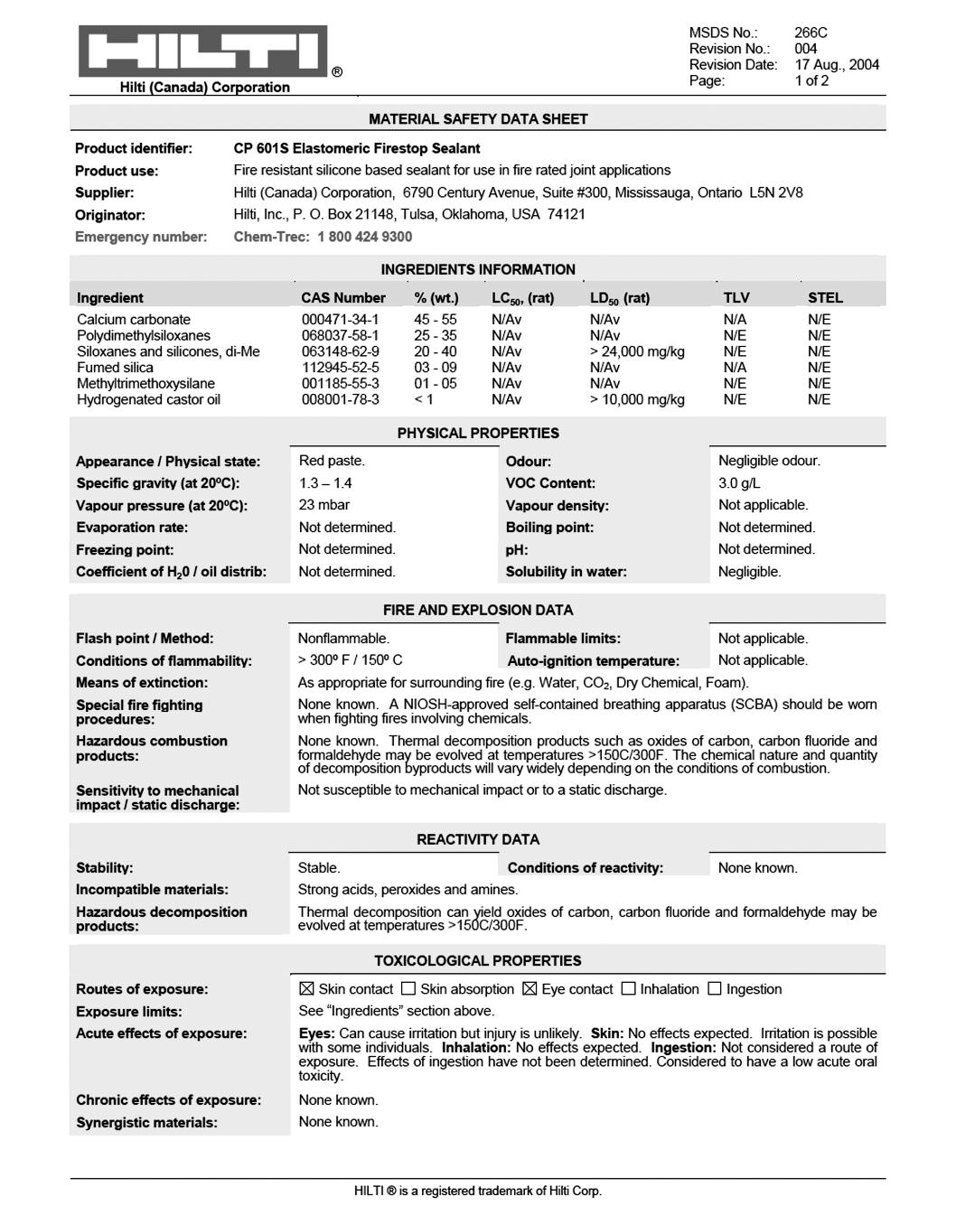

Retrieved from http://www.hilti.ca

Material Safety Data Sheets
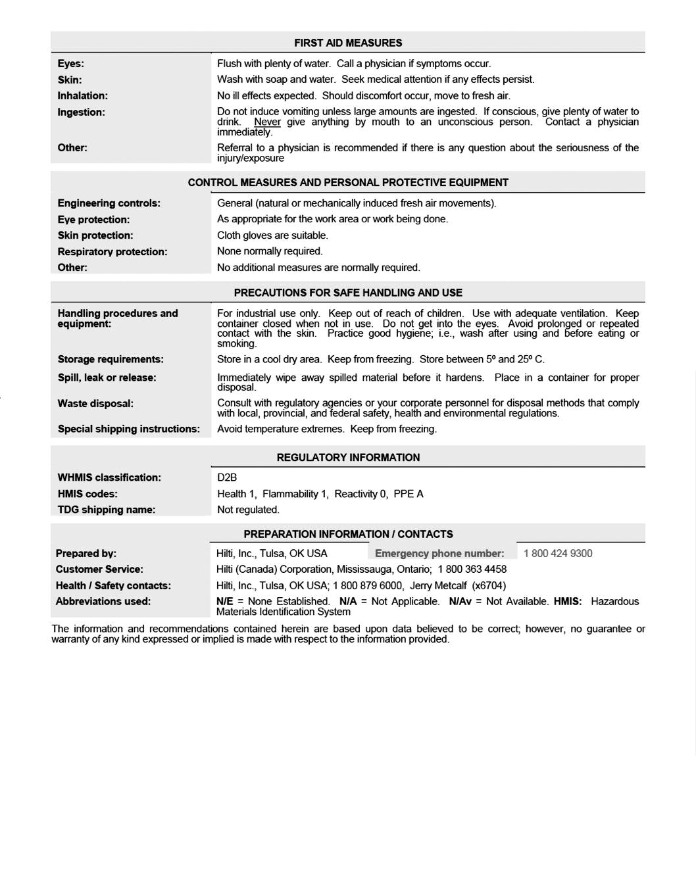

Retrieved from http://www.hilti.ca

E-mail Template

April 3, 2007 1:15:35 PM Subject: MSDS 266C
To: info@msds.com

2. Answer Key

Task 1
New products are constantly available. Insulators check product details to make sure that the product is well suited to how it will be used. Refer to the Product Details Sheet to decide if this product could be used in the situation below.

The insulator is replacing the insulation between floors in a hotel renovation. The pipes between the floors are 200 mm in diameter and there is enough space for a caulking gun. Although it is winter, the building has some heat during the repairs and the daytime temperature is 11˚C.

Instructions: Decide if the product is suitable for this situation. Explain why or why not.

Answer

This product can be used in this situation.

Essential Skills Focus: Decision Making - Level 2, Document Use - Level 1, Finding
Information - Level 1

Check page 30 for one way to get this answer.

Task 2
The insulator checks the MSDS for this product. Highlight the section on Handling procedures.

Answer

section: PRECAUTIONS FOR SAFE HANDLING AND USE
See Task 2 Answer Sheet

Essential Skills Focus: Document Use - Level 2, Finding Information - Level 1

Check page 32 for one way to get this answer.

Task 3

What personal protective equipment does the Insulator need to handle this product?

Answer

Cloth gloves and eye protection depending on the work area or work being done.

Essential Skills Focus: Document Use - Level 2, Finding Information - Level 1

Check page 33 for one way to get this answer.

Task 4
The MSDS seems to present different information about the health problems that could occur if the worker uses this product regularly over a long period of time. The insulator writes an
e-mail to the company to ask for clarification.
Instructions: Write an e-mail asking for information about the long-term health hazards. Include the product name, number, frequency of use, and identify conflicting information in the MSDS. Use the e-mail template on page 27.

Answer

Answers may vary.

Sample answer: See Task 4 Answer Sheet

Essential Skills Focus: Writing - Level 2, Reading Text - Level 2, Computer Use - Level 2

Check page 34 for one way to get this answer.

3. Answer Steps

Task 1
New products are constantly available. Insulators check product details to make sure that the product is well suited to how it will be used. Refer to the Product Details Sheet to decide if this product could be used in the situation below.

The insulator is replacing the insulation between floors in a hotel renovation. The pipes between the floors are 200 mm in diameter and there is enough space for a caulking gun. Although it is winter, the building has some heat during the repairs and the daytime temperature is 11˚C.

Instructions: Decide if the product is suitable for this situation. Explain why or why not.

Answer

This product can be used in this situation.

One way to get this answer...

- Identify criteria from the task about the situation.
• Between floors
• Pipes – 200 mm
• Space for caulking gun
• Winter
• Daytime temperature 11˚C

- List criteria in situation and similar information from the Product Details Sheet.

Situation | Product Requirements
Between floors | Applications: Joints in walls, floor to floor or fire compartments
Pipes – 200 mm | Pipe diameter: Up to 254 mm
Space for caulking gun | Method of application: caulking
Winter
Daytime temperature 11˚C | Application Temperature: 5 – 25˚C

- Decide that winter is not a criterion for using this product.
- Compare each criteria or item in the list.
• Between the floors is similar in meaning to floor to floor
• 200 mm is less than 254 mm
• Space for caulking gun means that the product can be applied
• 11˚C is more than 5˚C but less than 25˚C
- Decide that this product is suitable for this situation for the following reasons:
• Between the floors is similar in meaning to floor to floor
• 200 mm diameter is less than 254 mm
• Space for caulking gun means that the product can be applied
• 11˚C is more than 5˚C but less than 25˚C

Skill Focus: Decision Making - Level 2
Additional Skills: Document Use - Level 1, Finding Information - Level 1

Task 2
The insulator checks the MSDS for this product. Highlight the section on Handling procedures.

Answer

section: PRECAUTIONS FOR SAFE HANDLING AND USE

One way to get this answer...

- Scan the headings using the key words handling procedures.
- Locate the heading PRECAUTIONS FOR SAFE HANDLING AND USE.
- Decide that this section is about handling procedures.
- Highlight the section Handling procedures and equipment: For industrial use …or smoking.

Skill Focus: Document Use - Level 2
Additional Skills: Finding Information - Level 1

Task 3

What personal protective equipment does the Insulator need to handle this product?

Answer

Cloth gloves and eye protection depending on the work area or work being done.

One way to get this answer...

- Scan the headings using the key words personal protective, equipment and handle.
- Locate the heading CONTROL MEASURES AND PERSONAL PROTECTIVE EQUIPMENT.
- Decide that PPE is an abbreviation for Personal Protective Equipment.
- Scan this section using the keyword equipment.
- Locate eye protection and as appropriate for the work area or work being done.
- Decide that eye protection may be needed to handle this product depending on the work area or work being done.
- Locate skin protection and cloth gloves are suitable.
- Decide that skin protection equipment is cloth gloves and that they are needed to handle this product.
- Decide that eye protection may be needed depending on the work area or work being done.

Skill Focus: Document Use - Level 2
Additional Skills: Finding Information - Level 1

Task 4
The MSDS seems to present different information about the health problems that could occur if the worker uses this product regularly over a long period of time. The insulator writes an e-mail to the company to ask for clarification.
Instructions: Write an e-mail asking for information about the long-term health hazards. Include the product name, number, frequency of use, and identify conflicting information in the MSDS.

Answer

Answers may vary.

Sample answer: See Task 4 Answer Sheet.

One way to get this answer...

- Identify the purpose for writing: to request information to clarify long term health problems.
- Locate the audience: someone (Sir or Madame) at MSDS.
- Recognize that e-mails have a salutation, one or more paragraphs of writing, and closure.
- Write the salutation. State the product name, number, frequency of use.

Dear Sir or Madame
I am a worker using your product CP 601S. Because I use this product every day I am
interested in finding out more about the health problems that might occur from long-
term exposure.
- Explain the conflicting information in sentences.
Under Toxicological properties it says that no effects are expected from chronic
exposure. In the handling section it says “avoid prolonged or repeated contact with
the skin and cloth gloves are recommended”. I’m not completely familiar with HMIS
codes but the Health rating is 1 not 0 so some hazard is involved.
- Write the conclusion and ask for clarification.
I would appreciate clarification of the risk of this product to the skin or any other
risk I should be aware of at your earliest convenience. Thanks.

Skill Focus: Writing - Level 2
Additional Skills: Reading Text - Level 2, Computer Use - Level 2

Task 2 Answer Sheet

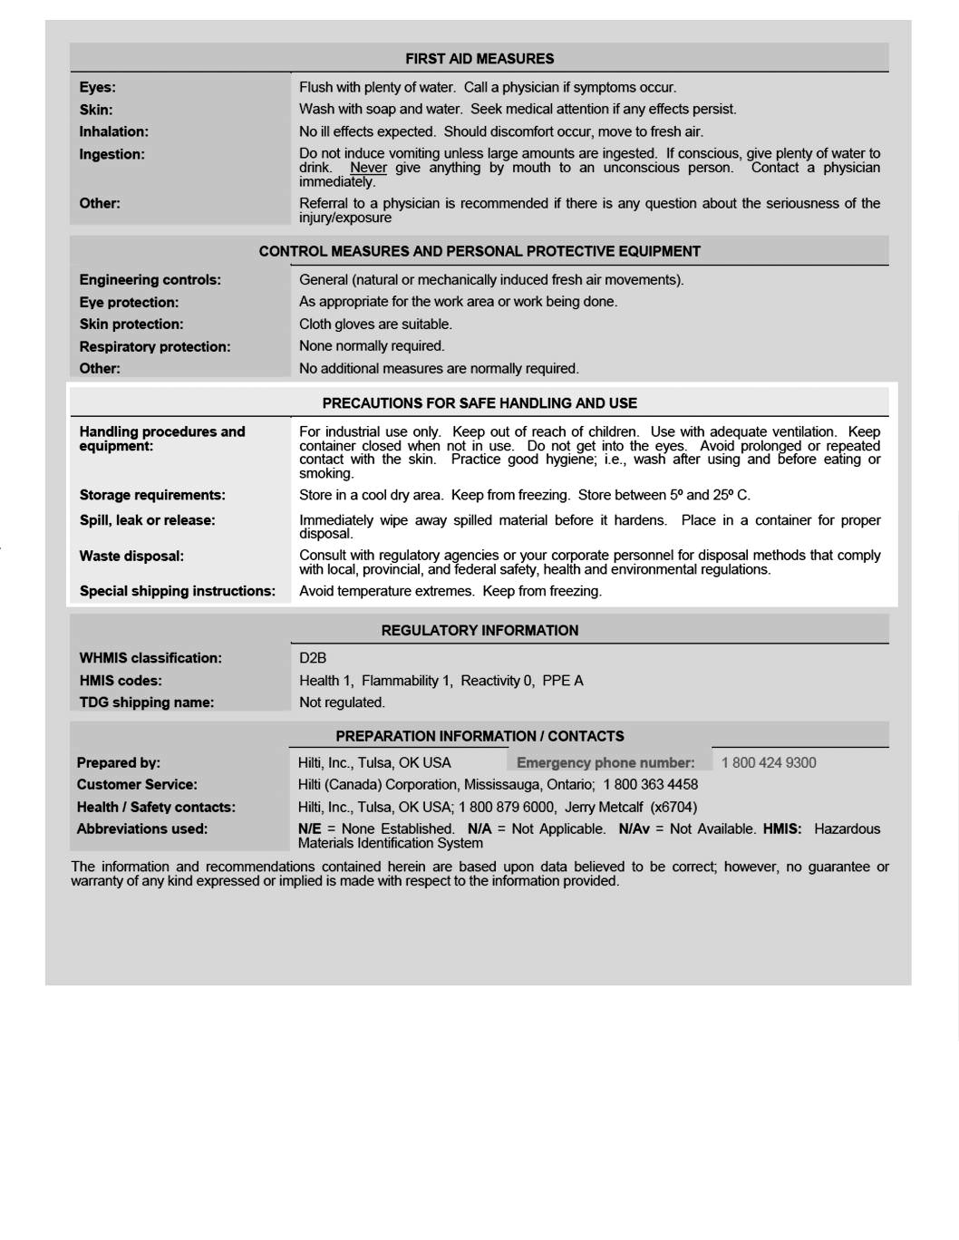

Retrieved from http://www.hilti.ca

Task 4 Answer Sheet

April 3, 2007 1:15:35 PM Subject: MSDS 266C
To: info@msds.com

Dear Sir or Madame,

I am a worker using your product CP 601S. Because I use this product every day I am interested in finding out more about the health problems that might occur from long term exposure. I have downloaded your MSDS No 266 and I have a few questions. Under Toxicological properties it says that no effects are expected from chronic exposure. In the handling section it says “avoid prolonged or repeated contact with the skin and cloth gloves are recommended. I’m not completely familiar with HMIS codes but the Health rating is 1 not 0 so some hazard is involved.

I would appreciate clarification of the risk of this product to the skin or any other risk I should be aware of at your earliest convenience.

Thanks.
Your name

Appendix 2: Additional Resources
Ontario Skills Passport – Use your Essential Skills and work habits to keep yourself safe at work: www.ontario.ca/skillspassport

Protect Yourself: Stuff You Need to Know
- In an emergency, always call 911 immediately.
(TTY: 1-855-653-9260)
- Call 1-877-202-0008 toll-free during business hours to ask a question and 24/7 to report any incidents to Ministry of Labour Inspectors.
Health and Safety
- Ontario Ministry of Labour: Young Workers
Ontario.ca/YoungWorkers
- Ontario Ministry of Labour: Health and Safety
Ontario.ca/HealthAndSafetyAtWork
- Canadian Centre for Occupational Health and Safely: Information on WHMIS/GHS Symbols
http://www.ccohs.ca/oshanswers/legisl/whmis_classifi.html
- Ministry of Labour – It’s Your Job Tips Sheet
http://www.labour.gov.on.ca/english/atwork/pdf/yw_tips_workplaces.pdf

Information About Work Refusals
- http://www.labour.gov.on.ca/english/atwork/yw_tips_workplaces.php
- http://www.e-laws.gov.on.ca/html/statutes/english/elaws_statutes_90o01_e.htm#s50s1
- http://www.worksmartontario.gov.on.ca/scripts/default.asp?contentid=2-4-3#H2

Section 43.(1) of OHSA Refusal to work A worker can refuse to work if he or she has reason to believe that one or more of the following is true:
- Any machine, equipment or tool that the worker is using or is told to use is likely to endanger himself or herself or another worker [section 43(3)(a)].
- The physical condition of the workplace or work station is likely to endanger the worker [section 43(3)(b)].
- Any machine, equipment or tool that the worker is using, or the physical condition of the workplace, contravenes the Act or regulations and is likely to endanger himself or herself or another worker [section 43(3)(c)].

Information about Reprisals
- http://www.labour.gov.on.ca/english/hs/pdf/fs_reprisals.pdf
- http://www.e-laws.gov.on.ca/html/statutes/english/elaws_statutes_90o01_e.htm#s50s1
Section 50 of the OHSA, an employer cannot
- dismiss (or threaten to dismiss) a worker
- discipline or suspend a worker (or threaten to do so)
- impose (or threaten to impose) any penalty upon a worker, or
- intimidate or coerce a worker because a worker has
- followed the OHSA and regulations
- exercised rights under the OHSA, including the right to refuse unsafe work
- asked the employer to follow the OHSA and regulations.

- Canadian Centre for Occupational Health and Safety: Health effects of methylene chloride
http://www.ccohs.ca/oshanswers/chemicals/chem_profiles/methylene.html

Occupational Health and Safety Act (OHSA)
Section 37. of the Act
An employer,
(1) (a) shall ensure that all hazardous materials present in the workplace are identified in the prescribed manner;
(b) shall obtain or prepare, as may be prescribed, an unexpired material safety data sheet for all hazardous materials present in the workplace; and
(3) An employer shall ensure that a hazardous material is not used, handled or stored at a workplace unless the prescribed requirements concerning identification, material safety data sheets and worker instruction and training are met.

Section 42(1) of the Act The law requires that the employer educate "a worker exposed or likely to be exposed" to a controlled product .
http://www.e-laws.gov.on.ca/html/statutes/english/elaws_statutes_90o01_e.htm

Regulation 860 - Workplace Hazardous Materials Information System (WHMIS)
Section 3.of WHMIS
(1) An employer shall assess all biological and chemical agents produced in the workplace for use therein to determine if they are hazardous materials
http://www.e-laws.gov.on.ca/html/regs/english/elaws_regs_900860_e.htm#BK2
Duties of employers
26. (1) carry out such training programs for workers, supervisors and committee members as may be prescribed.
http://www.e-laws.gov.on.ca/html/statutes/english/elaws_statutes_90o01_e.htm

